Agenda for Today:
- Topics from Last Week
- Migration Summary
- Update on Automation
- Curtisswright.com
  - Walkthrough of Weekly Web Analytics of Curtisswright.com
    - Google Analytics: Link
Summary Report For Migration Websites (Batch 3):
Website | Owner | Completed Tasks | Upcoming Tasks | Clarifications/Requests
CW Phase 2.0 - Planning | Sunil Kumar | Received pptx file from Darren.  Had a detailed discussed with CW-Defense understood their requirements  We analyzed the requirement of CW-defense  CW Defense — DS Web 2.0 : Requirements via Implementation - 20 Topics - Internal (To be shared with Dave)  Based on Weekly Discussion with the defense team, we are working on migration planning on merging Curtisswright.com and CW defense.  We will look at all the schema, data objects, and forms and do a detailed technical analysis on the merger of these two sites (including conflicts, issues, and naming or taxonomy changes).  Defense Analysis :  CW Web2 - Migration_Plan - DS | Internally discussed the design standards.  Creating a Drupal theme (CSS, JS specific to 2.0 mockups) will be installed on the 2.0 development site.  (Figma > Drupal Theme)  ---  Approved Templates by End of March 2026  (After Exec Review, Dev Starts by April 7th 2026) | Acquia environment setup for CW phase 2 ✅  https://cw-2-0-sandbox.curtisswright.com/sensors  CW Theme 2.0 ✅ (theme name : cw_2, cw_2_sub)  Modules ✅  Design ☑️  Phase 2.0 - Homepage Design preview Curtiss-Wright Phase 2.0 - Home page.pdfCurtiss-Wright Design product pages Web 2.0.pdf  Figma file link:  Division Pages updated Navigation  Web Phase 2.0 _ Navigation Corporate + Division.pdf  Brand Guide is completed ☑️  CW Web-2.0 Style guide updated.pdf  Style Guide_abbreviated.pdf (CW Copy)  We have reviewed the CW Style Guide.
CW Phase 2.0 : CW Common Theme Development | Sunil Kumar Britto Raj | We are working on a test site on Acquia, looking at all the Figma components and converting them to Layout Builder components. |  | https://cw-2-0-sandbox.curtisswright.com/sensors  Successfully migrated the Sensors website into CW 2.0  Converted Gavias Page Builder content into CW Sensors Layout Builder components ☑️  2 pages remaining for converting to layout builder component, ☑️  Testing has started ☑️  Login page designed ✅
WS CORP (Additional Nuclear Site)  Batch 4 | Sunil / Britto | https://www.ws-corp.com/  https://www.3keysoft.com/  Only 10 pages need to be added manually, so there is no need to start the migration now. Once they share the confirmation, we will start migration. | Site Summary Document | Site Summary Document ✅  Waiting for Stakeholder Response.  No updates this week.
CWST Translation Sites/Content | https://surfacetechnologies.curtisswright.com/  Nihar / Sindhu | Completed the translations for the French, Polish, Spanish, Chinese, and German languages. ✅ | Phase 2.0:  We have sent the Romanian and Hungarian translation pages to Amanda for review. | Phase 2.0:  Awaiting feedback from Amanda regarding the Romanian and Hungarian translations.  We have sent new translation pages for review, awaiting Amanda and Matyas' feedback on the Romanian and Hungarian translations. ☑️  No updates this week.
Searchstax | Rohan |  | A custom module is developed. ✅  https:/curtisswright.com/search | Analytics Report  Trending Now (Corporate): Updates are reflected across all pages using the common /search page. Page-specific Trending Now is not currently supported.
CWST - RFQ & Searchable Approvals Database | Divya | https://cwstcomdev.prod.acquia-sites.com/searchable-databaseapprovals  TG Approvals 2025 | Ref : https://www.valencesurfacetech.com/approvals/  For Database Approvals -Waiting for Client Inputs. ✅  The database sheet will be shared by July 3rd week. | https://cwstcomdev.prod.acquia-sites.com/contact-us/rfq  RFQ Form is Completed for English Version.☑️  Working on translating other languages.  Working on the RFQ module translation configuration.
SEO Optimisation for curtisswright.com | Sofia Krishnan | - Completed on updating missing ALT tags for Nuclear ✅  Missing Image Alt tags | - Working on meta titles & meta description for curtiss wright & other business sites | Sofia is working on the SEO Analysis of CW Business Sites (We have completed Surface Tech earlier)
Everlube | Divya M | everlubeproducts.com | Everlube Site Summary Document | Evaluation of the site is completed and sent for review. ✅  No updates this week.  Migration will be started from Next week
IMR test Labs  http://imrtest.com/ | Shilpa Patil | IMR Site Summary Document  Completed Layouts : 0/52  Completed Pages Migrated: 0/182 | Pending layouts: 52/52  Pending Pages : 182/182 | Started Working on Home page layout Design
Keronite | Britto Raj | keronite.com | keronite Site Summary Document | Evaluation of the site is completed and sent for review. ✅  No updates this week  Migration will be started from Next week

Summary Report For Live Websites :
Website | Open Items | Clarifications/Requests | Resolved Issues / New Updates
Curtisswright.com  https://curtisswright.com  Live ✅  Monitoring and Supporting. | No Open Issues |  | Content Updates on Curtisswright.com:  Weekly Content Summary - CW WS CoE - 2 July 2026
CWST  https://cwst.com  Live ✅  Monitoring and Supporting. | No Open Issues |  | No open items.
CW Sensors  https://cw-sensors.com  Live ✅  Monitoring and Supporting. | No Open Issues |  | No open items.
CW Industrial  https://cw-industrial.com  Live ✅  Monitoring and Supporting. | No Open Issues |  | No open items.
Sunrise PGDT  https://sunrise.pgdrivestechnology.com/  Live ✅  Monitoring and Supporting. | No Open Issues |  | No open items.
Support PGDT  https://industrial.curtisswright.com/en-gb/pgdt  Live ✅  Monitoring and Supporting. | No Open Issues |  | No open items.
SSRT  https://industrial.curtisswright.com/ssrt/user/login  Live ✅  Monitoring and Supporting. | No Open Issues |  | No open items.
Powerchair Manager  https://industrial.curtisswright.com/en-gb/powerchair-manager  Live ✅  Monitoring and Supporting. | No Open Issues |  | No open items.
CW Valves Group  https://valves.curtisswright.com/  Live ✅  Monitoring and Supporting. | No Open Issues |  | No open items.
CW EST  https://valves.curtisswright.com/en-us/EST  Live ✅  Monitoring and Supporting. | No Open Issues |  | No open items.
CW Nuclear  https://www.cwnuclear.com/  Live ✅  Monitoring and Supporting. | No Open Issues |  | No open items.
CW EMS  https://cw-ems.com/  Live ✅  Monitoring and Supporting. | No open issues |  | No open items.
CW Actuation  https://www.cw-actuation.com/  Live ✅  Monitoring and Supporting. | No open issues |  | No open items.
Sensors & Actuation  https://sensors-actuation.curtisswright.com/  Live ✅  Monitoring and Supporting. | No open issues |  | No open items.
CW Defense  https://www.curtisswrightds.com  Live ✅  Monitoring and Supporting. | No open issues |  | No open items.
CW Actuation Portal  https://portal.cw-actuation.com/  Live ✅  Monitoring and Supporting |  | Live: portal.cw-actuation.com | Currently working on the modal and price configurator for the new products: GSX, SLM, SLG, T2X, R2G, R2M, RDG, and RDM. ☑️  Bonnie asked for two APIs related to orders: ☑️  - An API to provide the price details for all orders.  - An API to track how many users checked a quote before it is submitted.  Added the PDF to the Presentations and Logos sections in the staging environment.

Topics from Last Week
Topic | Details | Question/Clarification/Update
Few Low Priority Topics |  | CW June/July 2026 Events ?
Bluefly Topics  Accessibility & SEO Improvements  Performance Optimization | Rasheed suggested CW SEO Topics and Scope. | CW <> Bluefly <> Etag - Topics Tracker  - Security update, security kit module completed by Friday  - Working on Press release Date appending with title for all press releases on live site. (Completed year - 2002 to 2020) ☑️  - Webform Module: The Counter Problem ☑️
Manage Service Request Through CW Channels only |  | Stop using @etag.in for responses after July 15.  Manage service / support requests from @curtisswright.com email addresses  Starting July 15, configure an auto-reply from curtisswright@etag.in  Instructing senders to raise all Web CoE support requests through the new help desk email or ServiceNow system.
Bootstrap vulnerability issue | Bootstrap version to be updated on all sites | Updated on CW and Divsion live site ✅
polyfill.io | We have identified that the curtisswrightcom.prod environment is loading JavaScript from polyfill.io, which is flagged in Drupal security advisory PSA-2024-06-26 due to potential security risks. This script is being introduced via the Webform module for older browser compatibility. Removed this dependency across CW and all Division sites as part of the remediation. | Updated on CW and Divsion live site ✅

Analytics, Monsido, and Webmaster Console:

Analytics | https://analytics.google.com/analytics/web/#/p432579895/reports/intelligenthome
Webmasters Console | https://search.google.com/search-console?utm_source=about-page&resource_id=sc-domain:curtisswright.com
Monsido (Acquia Optimize) | https://new.monsido.com/

Analytics
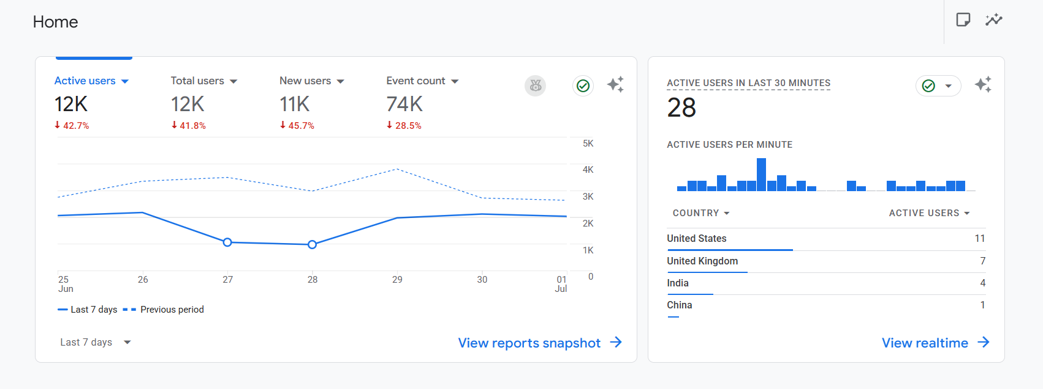
Monsido

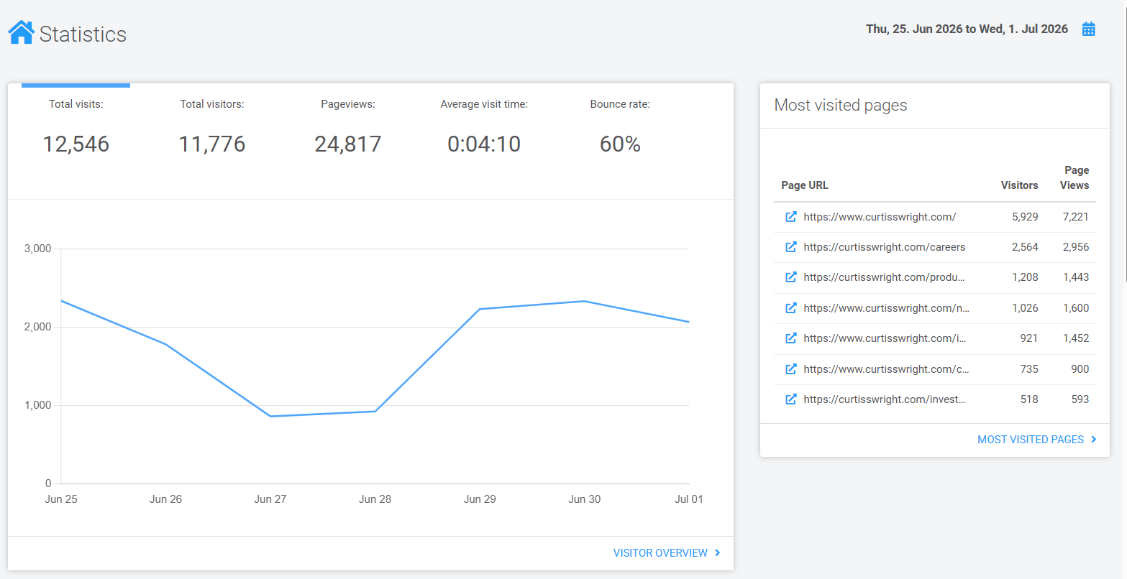

Search Stax
All Application
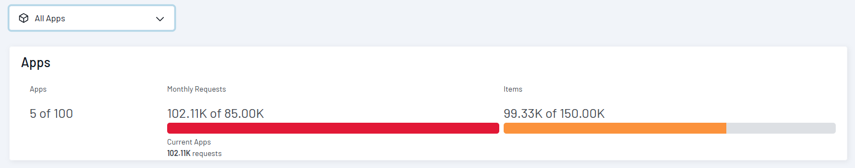
CW Live
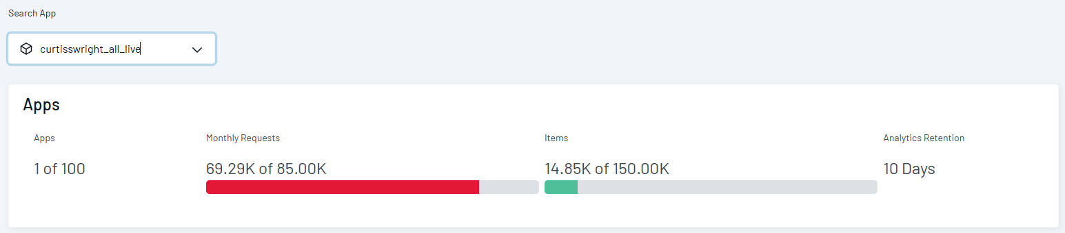
Inside CW Prod
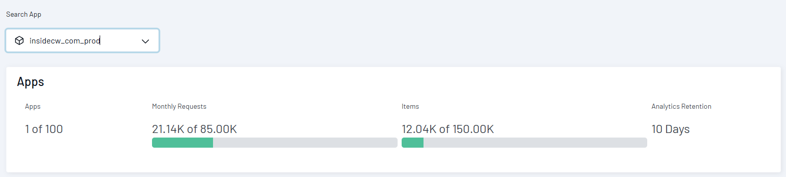

Dave’s priority list 2025

Topics | Owner | Status
Corporate - Add Veterans section to Careers | Divya M | Need to Start.
Global Search / Global Navigation | Sunil KumarRohan Gurav | - All the sites are now live with the SearchStax custom module implemented. ✅
Valves consolidation go-live | Divya MShilpa Patil | Went live ✅
Migration of cw-ssrt.com and powerchair-manager.com from Dreamscape (deadline approaching based on hosting) | Shilpa Patil  Britto Raj | SSRT went live ✅  Powerchair manager went live✅
Non-time-sensitive content change requests |  | Actively managed till 4PM EST Every Business day
CWST translations | Sindhu NJ  Nihar Ranjan Nayak  Divya M | The site is live. ✅
Actuation portal improvements  Migration of tools.exlar.com | Rohan Gurav | LMS  - This feature is in the roadmap
Actuation translations | Sindhu NJ  Nihar Ranjan Nayak  Shilpa Patil | Translation is on hold.
Migration of 3keysoft.com | Sunil Kumar | Site Summary Document ✅  Waiting for the stakeholder’s response. As per our discussion, only 10 pages need to be added manually, so there is no need to start the migration now. Once they share the confirmation, we will start Migration.
Centralized ticketing system to allow routing content change requests for approval | Rohan Gurav | This feature is in the roadmap

